|  |  |
| --- | --- |
|  |  |
| **Visualization Analysis:**  **COVID-19 Vaccine** |  |
|  |  |
| **COS30045 – DATA VISUALISATION** | SYED OMAIR MAQDOOM MOHIUDDIN  ID: 102863768 |
|  | Word count: 1640 |

**Executive Summary**

Visualization (Data) is the method of converting(abstract) data into visual presentations like interactive graphs for the purpose of discovery, validation, or representation. Using visualization methods to visualize large volumes of complex data is simpler than other methods since information is interpreted by the human brain. Visualization methods are simple and convenient to express universal concepts. Visualization aids in the detection of potential that needs attention, as well as the comprehension of goods and the clarification of the variables that impact consumer behavior. This report discusses visualizations in regards with COVID-19 Vaccine. Key concepts which include purpose of visualization, use of Visualization in understanding features and key aspects of data, any issues depending on the data type chosen, analysis and evaluating different visualizations are discussed in this report. Popularity of data processing, as well as big data initiatives, has increased the importance of visualization. Visualization helps speeding up the process and present the data to users more affectively which helps the human cognition to grasp the data quickly.

Contents

Introduction 3

Purpose 3

Key Terms 3

Body 4

Visual Analysis 12

Critique 13

Conclusion 13

References 14

# Introduction

## Purpose

The purpose of this report is to provide the importance of visualization in day-to-day life. Benefits of data visualization, its user’s, usage of visualization. Data visualization used in various industries to validate, discover, and present data. Appreciating role of visualization in tackling requirements due to technological innovations (Data analysis, dealing with Big data). The major purpose of this report is to explain how visualizations helps to tackle covid-19 outbreak.

## Key Terms

1. Data Visualization: representation of information in graphical (interactive) form.
2. Covid-19: An outbreak of virus which has a severe impact worldwide.
3. Data Analysis: Process of validating the data with objective of discovering critical information and finding conclusions.
4. Big data: Extremely huge sets of data with complex structure and patterns.

Using different visualization elements like maps, graphs and charts users can covey the patterns, trends, and any outliers in the data. Visualization techniques and methods plays a crucial role for large volumes of data and making decisions as required. It is an effective way to communicate while dealing with Big data. Mapping is an important skill for data visualization because the design of map might hinder the understandability of a document. Mapping aids in determining how certain elements element’s attributes vary based on the results. For effective communication data visualization contain vivid range of visual such as, usage of graphs, charts, statistical plots and many more. For the quantitative data like numerical data, dots, bars, and lines are used for better interaction and communicating quantitative and qualitative message. Using visualization complex data becomes much more available, interactive, and understandable and provided quick way of communicating the data.

# 

# Body

**Visualization – 1**

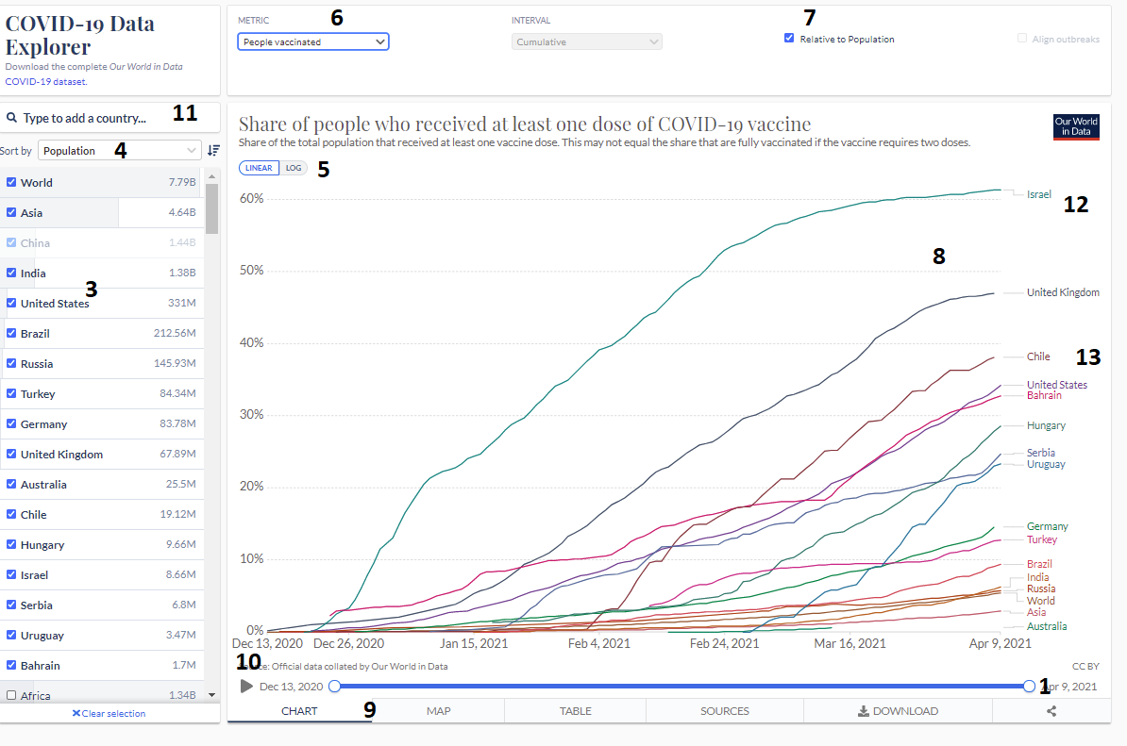

Figure 1: Visualization for covid-19 vaccine (source: <https://ourworldindata.org/covid-vaccinations> )

The purpose of visualization is to help understand the reader about the COVID-19 vaccinations all over the world. Numbers are provided in the figure for some interactions. Below are some interesting interactive features identified from the visualization:

1. Data can be adjusted as per the requirement. This helps to find out the vaccination percentage in a particular period of time.

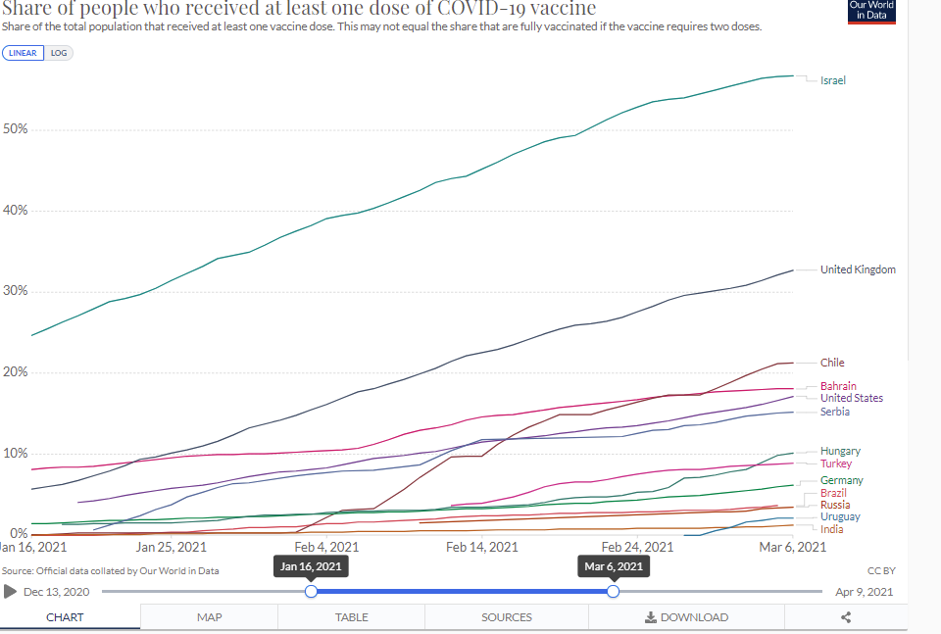

Figure 2: Adjusting level of dates in the visualization

1. Adding the source information helps the reader understand the data more accurately.

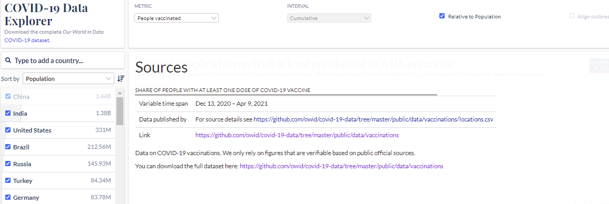

Figure 3: source of data

1. Check boxes are provided for different selections based on the choice of user. (Ex: World VS Continent VS Country)
2. Sort by option provided to choose for the data for the visualization.

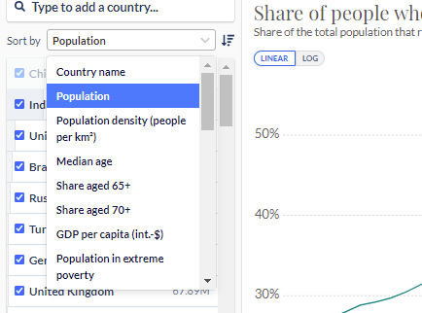

Figure 4: Sort by option for various data

1. Buttons provided to choose the data type (Linear VS Log)
2. Various matric drop down provided for selection of data

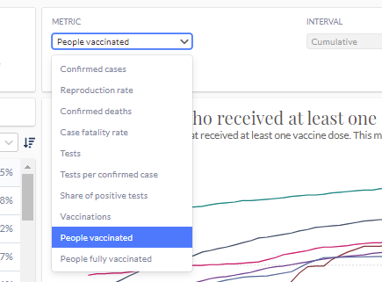

Figure 5: Drop down for metric data

1. Check box provided to select if the visualization is relative to population or based on people. Also the title of the visualization changes as per the selection

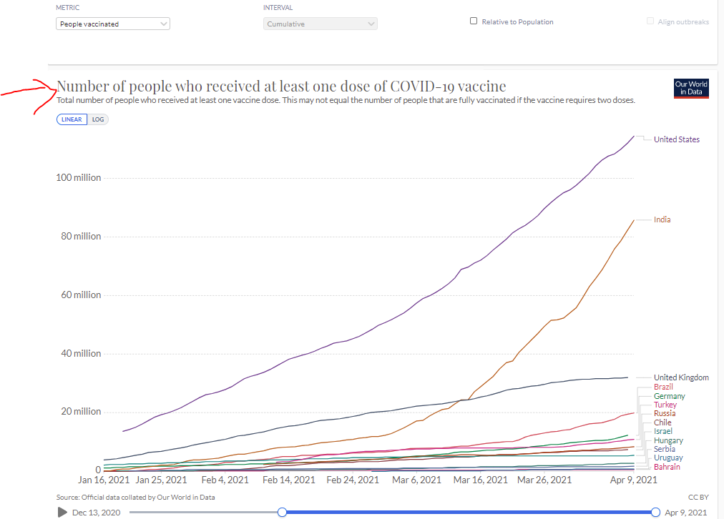

Figure 6: Number of people VS Total Population

1. Hover option provided in the visualization (line graph), shows the data if hover over a date.

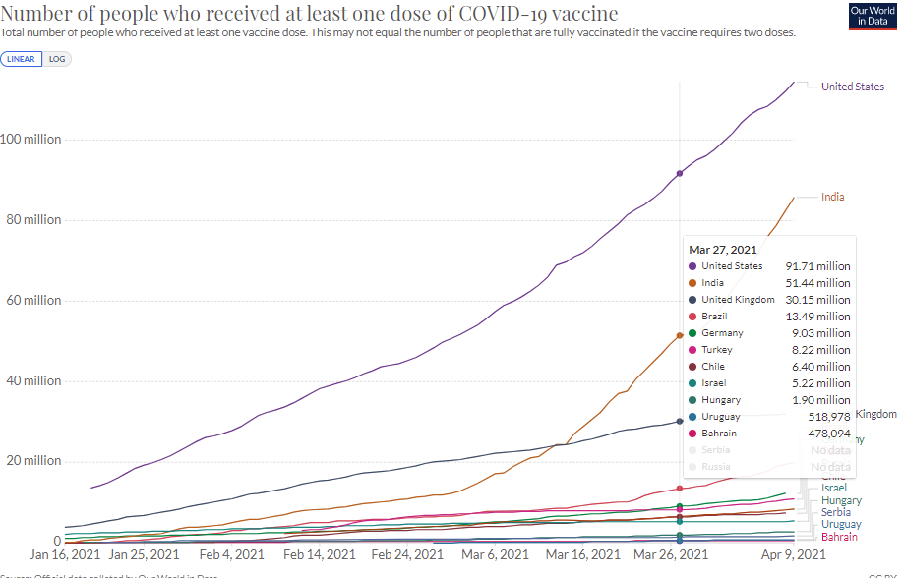

Figure 7: Hover feature

1. User can switch between different visualizations (Chart to Map to table) as required. Also, various features available in other visualization (Map), clicking the desired data(location) and you get the line graph of the data.

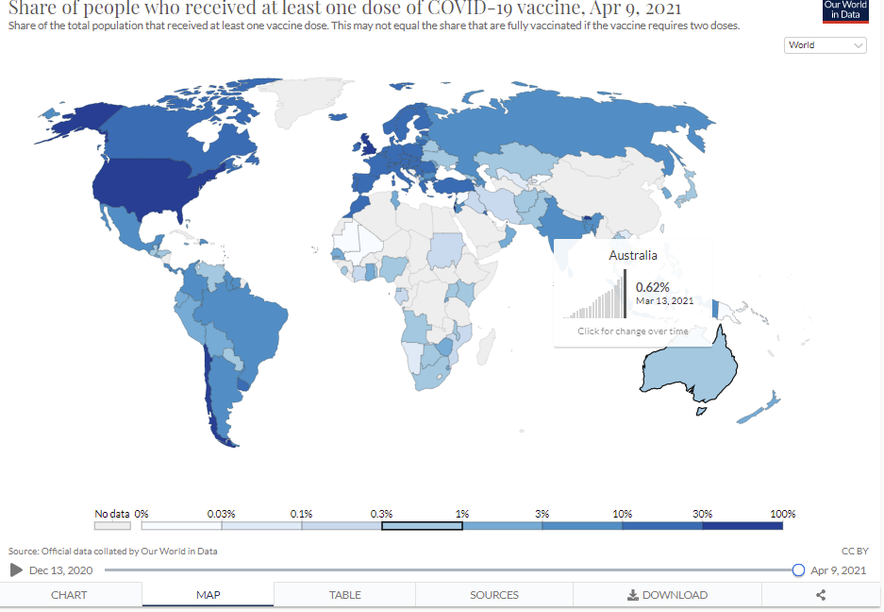 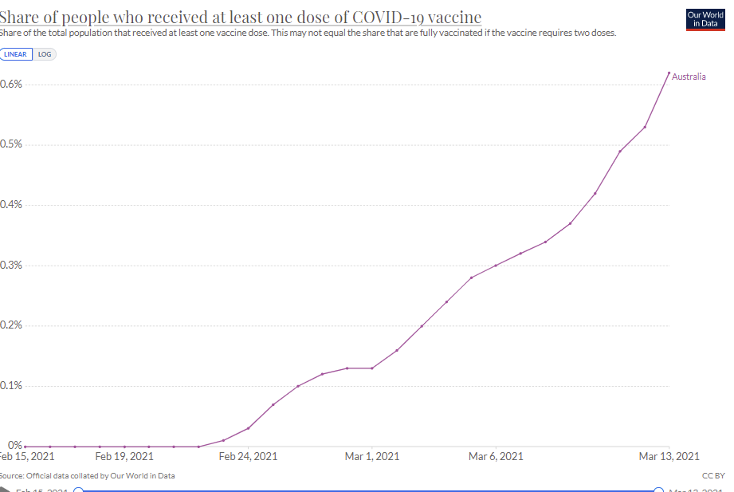

Figure 8: various Visualizations provided

1. Continuous visual of data with transitions is provided when the play button is clicked.
2. Search Functionality provided for better user experience to choose the desired location.
3. Hover over the desired location and you get the single line of graph for the location.

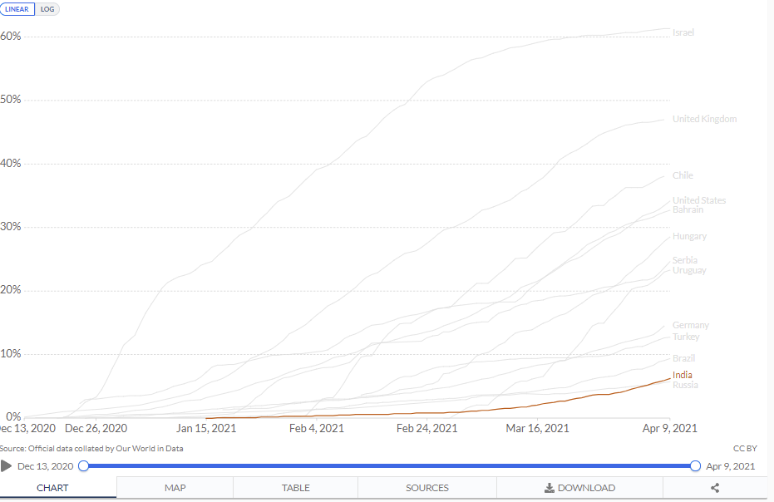

Figure 9: Hover over location

1. Choose the required location by just hovering over it.

Each visualization provides some critical information to the reader. Using the visualization of Map (World) we can say which part of the world has highest, moderate, and low vaccinations by just looking at the colors. Using the chart, we get to compare the vaccinations as required. Get to know the rate of vaccinations in every part of the world. It helps the medical researchers to know how well the vaccine is working, helps business organizations in planning future steps in regards with the vaccinations. Not only with the vaccinations, but the visualization also provides various data such as people infected, tested, fatality rate, vaccinated, confirmed deaths and many more. This helps the world tackle the harmful virus. The intended audience is the population of the world, medical researchers, medical organizations, news-media, and many other.

**Visualization – 2**

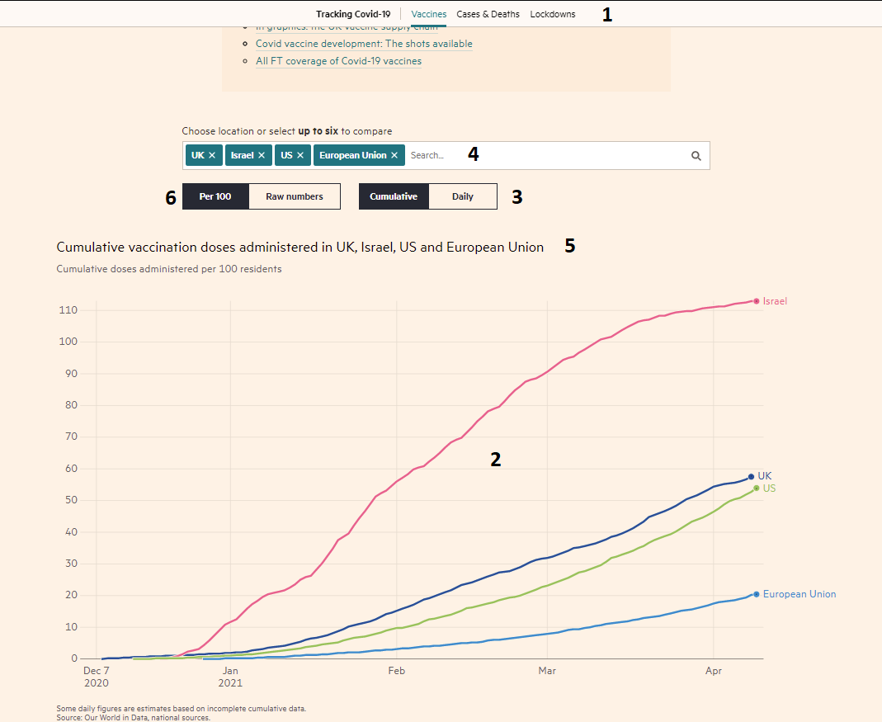

Figure 10: visualization (2) of covid-19 vaccination (Source: <https://ig.ft.com/coronavirus-vaccine-tracker/?areas=gbr&areas=isr&areas=usa&areas=eue&areas=aus&cumulative=0&populationAdjusted=1> )

Numbers are provided in the figure for some interactive features in the visualization, although it has quite few features in comparison with visualization-1. Below are some interesting interactive features identified from the visualization:

1. Visualization data can be changed by click the required data. This option is available through the page for the better interaction of user with the page.

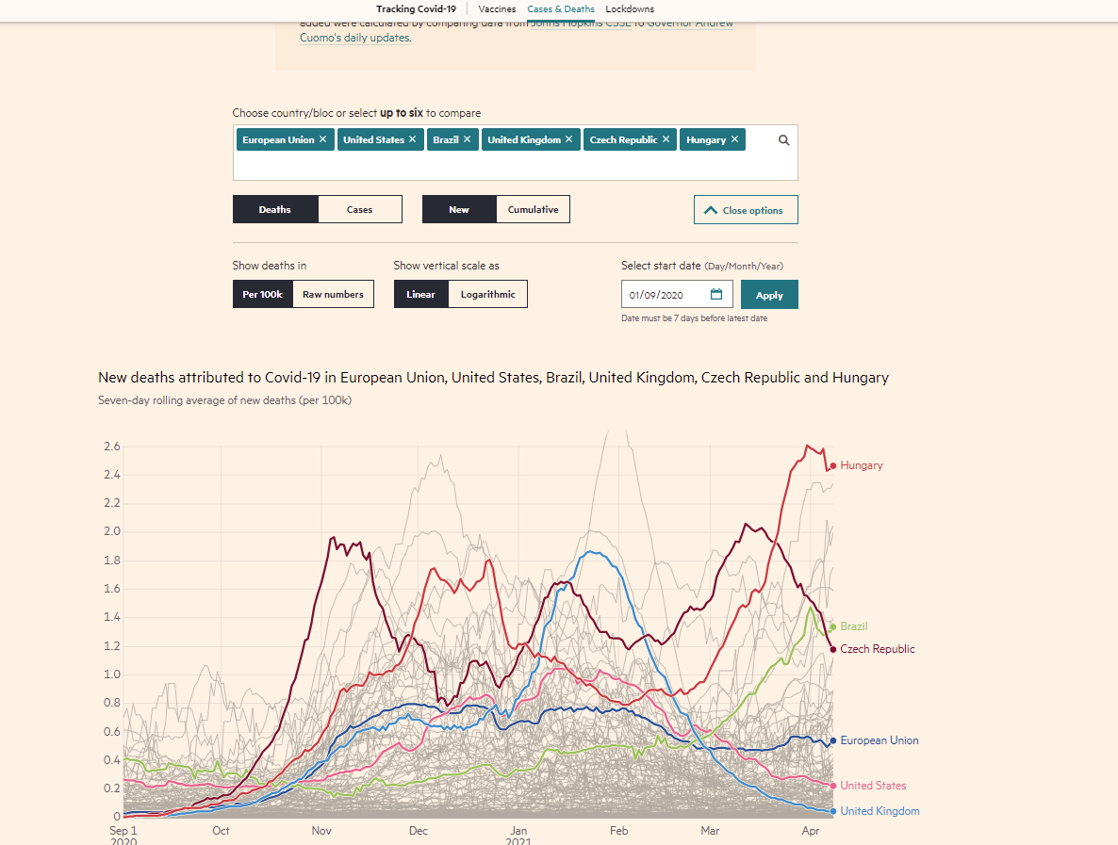

Figure 11: Options provided to choose the data for Visualization.

1. Interactivity provided for hovering over the individual line to get specific data of the location at a particular date.

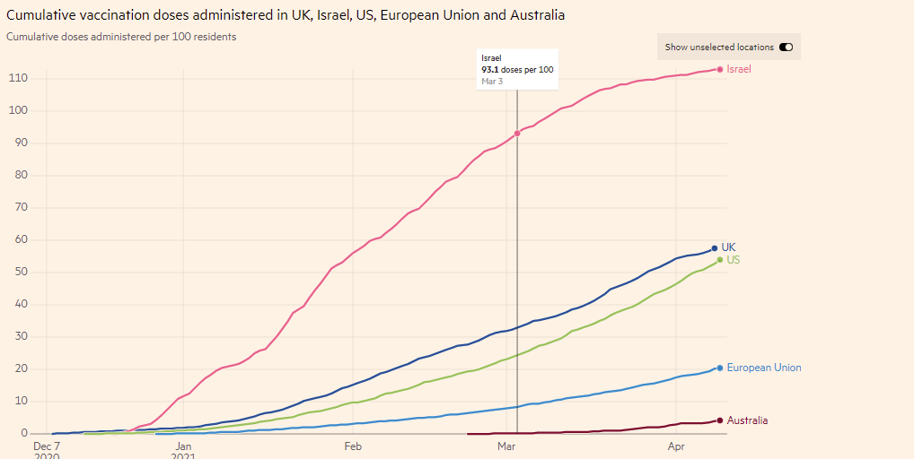

Figure 12: Hover over each individual location

1. Cumulative data VS Daily data

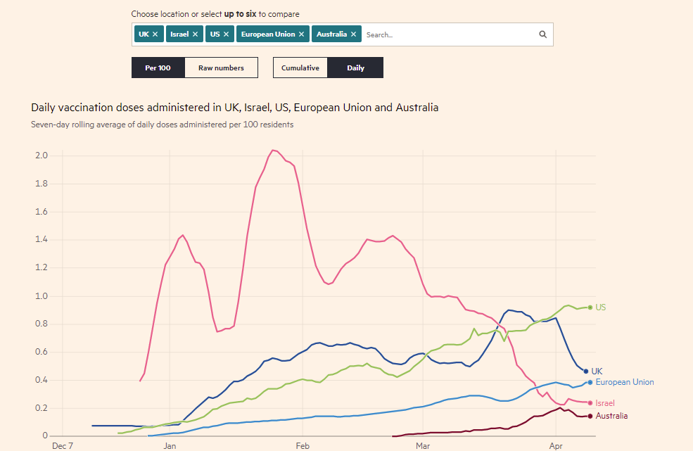

Figure 13: cumulative VS Daily Data

1. Search functionality provided to search for desired location.
2. Heading changes as per the selected information.

The purpose of the above visualization is to help the reader understand the data collected from worldwide on covid-19 vaccination. Various provided in the visualization increase the interaction between user and visualization. It helps the user understand the trends, develop statistical patterns, and find outliers in data. The visualization helps the user find the errors, explore business insights.

## Visual Analysis

Data was stored in CSV format. The vaccination data contains information like location (string), date (date), vaccine (categorical), source of the information, total_vaccinations (ordinal), people_vaccinated (ordinal) and people_fully_vaccinated (ordinal). HTML, CSS, SVG, Java Script are some programming languages used for encoding of visualization. Using a CSV file and writing a script which takes the data from the CSV file. This is a good practice to be followed, because everyday the data changes and do not need to change the code as per the data. We just change the data file and run the script. Visualization-2 has too little features when compared to visualization-1, also the search is limited to just 6 location, issues are raised when dealing with data of several locations. The scale provided for visualization-2 is not accurate. It increases without any trend.

## Critique

The visualization is very affective. It helps the user understand the data quickly and easily. The visualization answers all the questions of the user. The data can be read precisely in the visualization. In my pint of view the visualization does not misled the user in any aspect. Both the visualizations are well organized, coherent, consistent within the inclusive visualization, accurate, very helpful to the audience and scalable. Usage of different colors that help identify various trends in the data.

Both the visualizations are good with proper interactions and are user friendly. In Visualization-2 accurate scale should be provided for x-axis, search functionality should be updated, and the limit of search should be removed.

# Conclusion

Distribution of vaccine is critical in determining the efficacy of vaccination programmers. Visualization techniques have been used previously to determine disease patterns, hotspots of viruses and patterns of spread were established. Data visualization assists with monitoring vaccine rates in different areas. Human brain processes visualized information quickly than words and is extremely affective to perceive differences as well as make distinctions between colors, forms, proportions, and amounts. Visualizing data with graphs, maps, icons, and infographics will aid in the effective and consistent communication of complicated data, assisting the viewer in better understanding and recalling the information, and persuading them to take the desired steps. Visualization aids in the identification of areas that needed change of focus, as well as the comprehension of goods and the clarification of variables that affect consume behavior. Visualization should be effective, should be able to answer the questions of the user, particularly follow good design principles and never mislead the user.

# References

Po, Laura, et al. *Linked Data Visualization : Techniques, Tools, and Big Data*, Morgan & Claypool Publishers, 2020.*ProQuest Ebook Central*, <https://ebookcentral.proquest.com/lib/swin/detail.action?docID=6145032>.

Ward, Matthew O., et al. *Interactive Data Visualization : Foundations, Techniques, and Applications*, CRC Press LLC, 2010.*ProQuest Ebook Central*, <https://ebookcentral.proquest.com/lib/swin/detail.action?docID=1633669>.

Telea, Alexandru C.. *Data Visualization : Principles and Practice, Second Edition*, CRC Press LLC, 2014.*ProQuest Ebook Central*, <https://ebookcentral.proquest.com/lib/swin/detail.action?docID=1605634>.

Sahay, Amar. *Data Visualization : Uncovering the Hidden Pattern in Data Using Basic and New Quality Tools*, Business Expert Press, 2017.*ProQuest Ebook Central*, <https://ebookcentral.proquest.com/lib/swin/detail.action?docID=4819435>.

**Data Reference:**

Visualization-1

<https://ourworldindata.org/covid-vaccinations>

Visualization -2

<https://ig.ft.com/coronavirus-vaccine-tracker/?areas=ind&areas=zzz&areas=aus&cumulative=1&populationAdjusted=0>

**Data used in visualization:**

<https://github.com/owid/covid-19-data/tree/master/public/data/vaccinations>